**CRM Testing**

**Admin Login**

1. Login
   1. Remember me is not working
   2. Option to see password (that eye-sign)
   3. Too simple?
2. The main search bar is not working
3. Notifications are not clickable
4. Manage Leads
   1. Add New Lead
      1. Why only 2 genders?
      2. No checks on entering data. All fields with entry “1” was accepted except email.
      3. Format guidance on entering details
   2. Bulk upload leads
      1. Sample Format files are missing
      2. While bulk upload, entries add on random positions, there should be an indication of how many new entries are added.
      3. Email address/ gender is wrongly added during bulk upload, just numeric values. (upload sample file might address this issue + there should be some checks)
      4. Failed to upload CVS file
      5. The exact same entries as bulk were also uploaded successfully.
   3. View all leads
      1. Not all the added information is displayed (data of all the fields should be displayed)
      2. Sort by name, last name, date etc
      3. Filter data

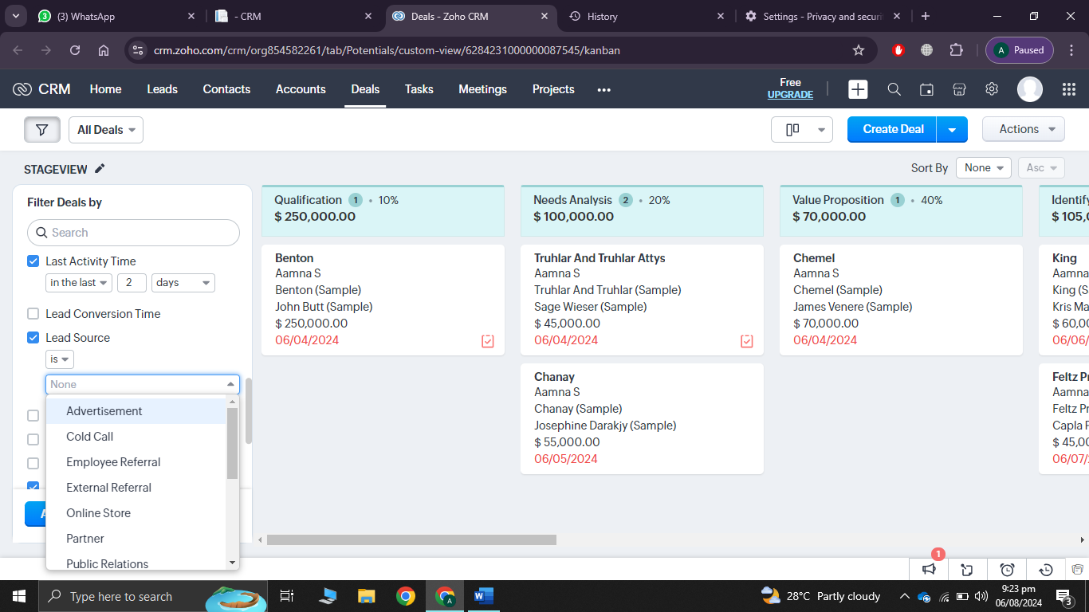

* 1. Allocated leads
     1. No edit/ update option for re-assignment
  2. Un-Allocated leads
  3. Lead History
     1. Follow up date

1. Our customers
   1. Sort by name, last name, date etc
   2. Filter data
2. Manage branches
3. Team and Referrals
   1. Delete/ update option is missing
   2. Why only 2 genders?
   3. No checks on entering data. All fields with entry “1” was accepted except email and password
   4. How to add more “Team member Type”
   5. Format guidance on entering details
4. Uni & Programs
5. “University Offering Various Programs” buttons are not working
6. Course credit hours are missing
7. Students
   1. Add/ delete/update option
8. User activity
9. Reports
   1. Summary reports
   2. advanced sorting filters
   3. Save/ export reports
10. 2x times following happened.

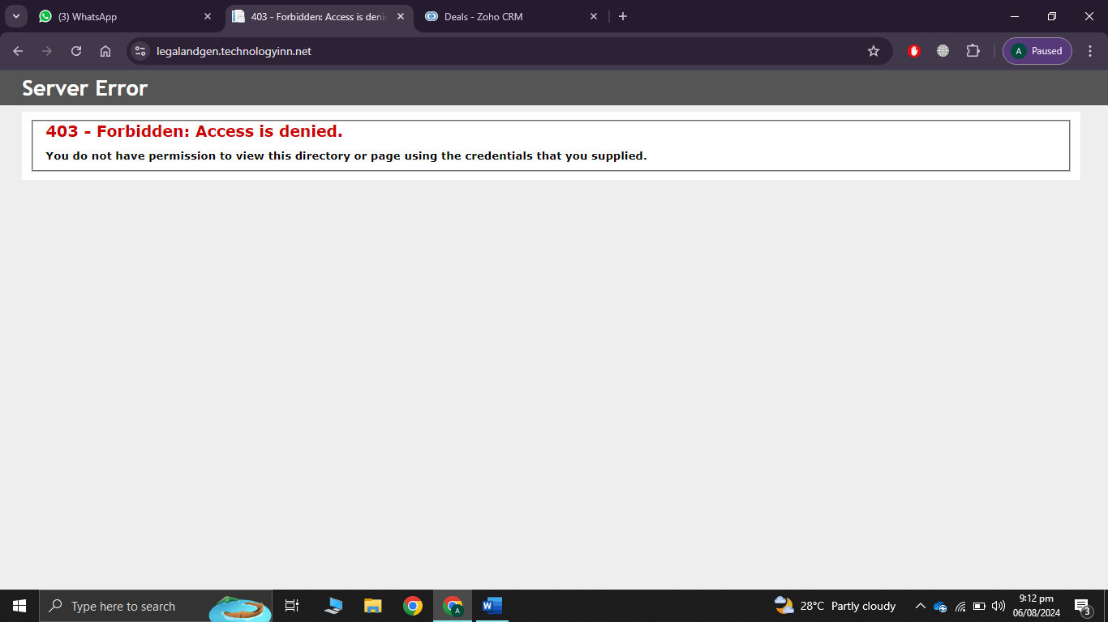

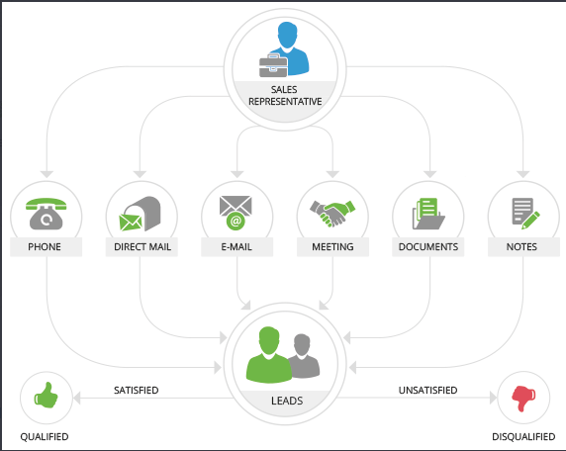

1. Dashboard showed 3 My leads, total leads in system are 6.
2. Calender Meeting
   1. Time of Meeting is not handled
   2. Also

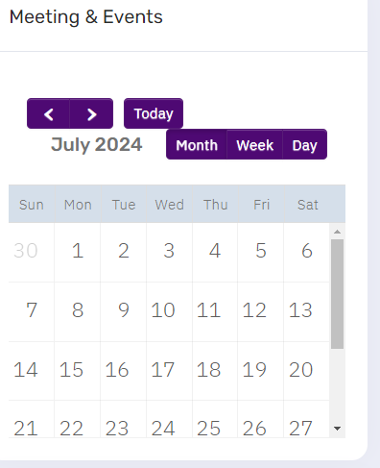

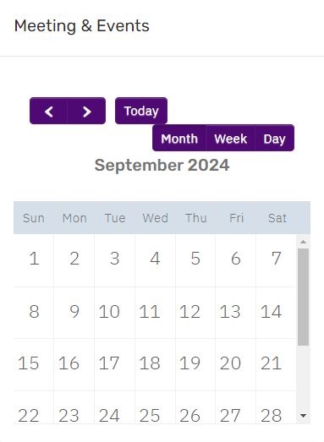

1. Activity logs can be placed at bottom left
2. Admin should have a password reset option for team members.
3. Can admin change team member of assigned lead?
4. Purpose of graphs on dashboard? And summary shown is not clickable. I should go to details on click.
5. Activity log on dashboard should display all activity logs of all user with respect to time.
6. Seach bar of some tabs are not working

**New team member**

[abcd@gmail.com](mailto:abcd@gmail.com)

Abcd@1234!

1. No Notification (Admin assigned the lead)
2. Branch on header is clickable but goes to this page:

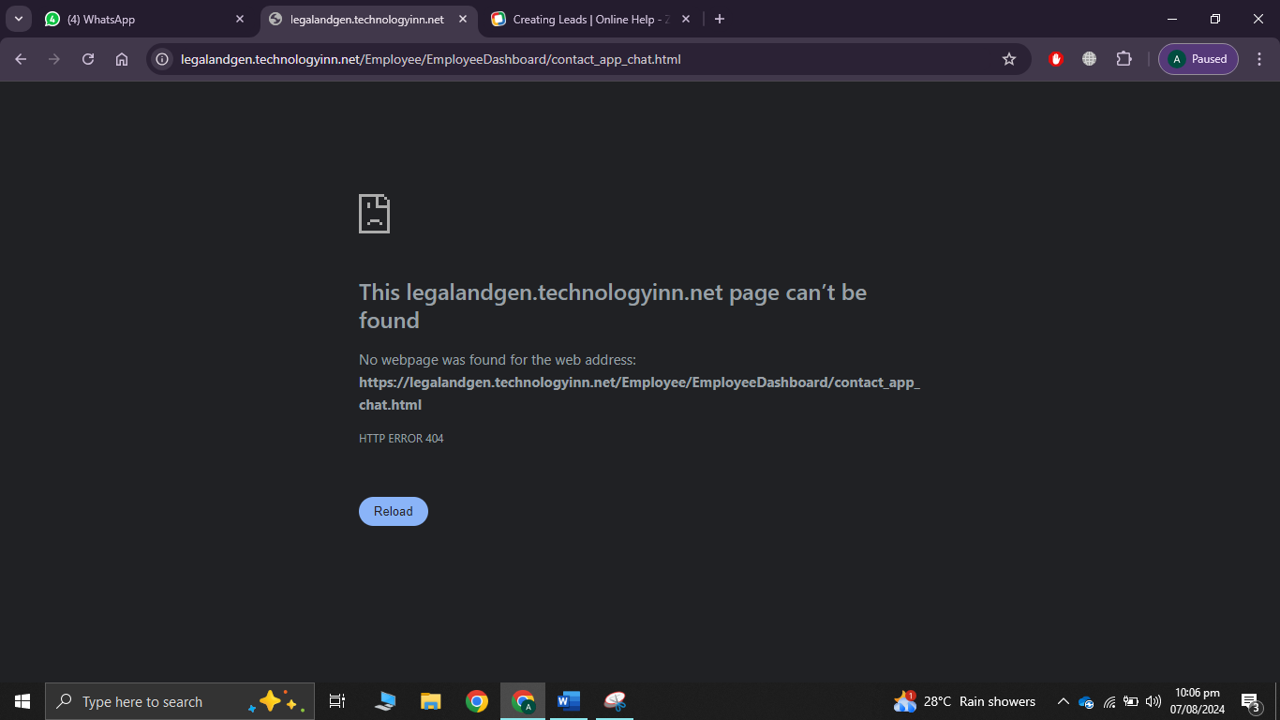

1. Same above after clicking on “welcome: name”
2. Created new team member and assigned one lead to this account, no notification was received and the dashboard showed 3 My leads

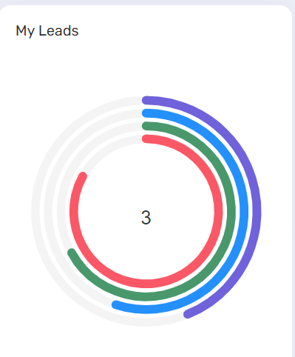

1. Time of meeting?
2. Can a team member or admin update lead status? If accidently select wrong status?
3. Changed Lead status but activity logs on dashboard display no logs.
4. Added follow-up for lead but same, no logs.
5. Activity log on Admin dashboard showed only one log from above two activities of team member.
6. Seach bar of some tabs are not working
7. Reports
   1. Summary reports
   2. advanced sorting filters
   3. Save/ export reports